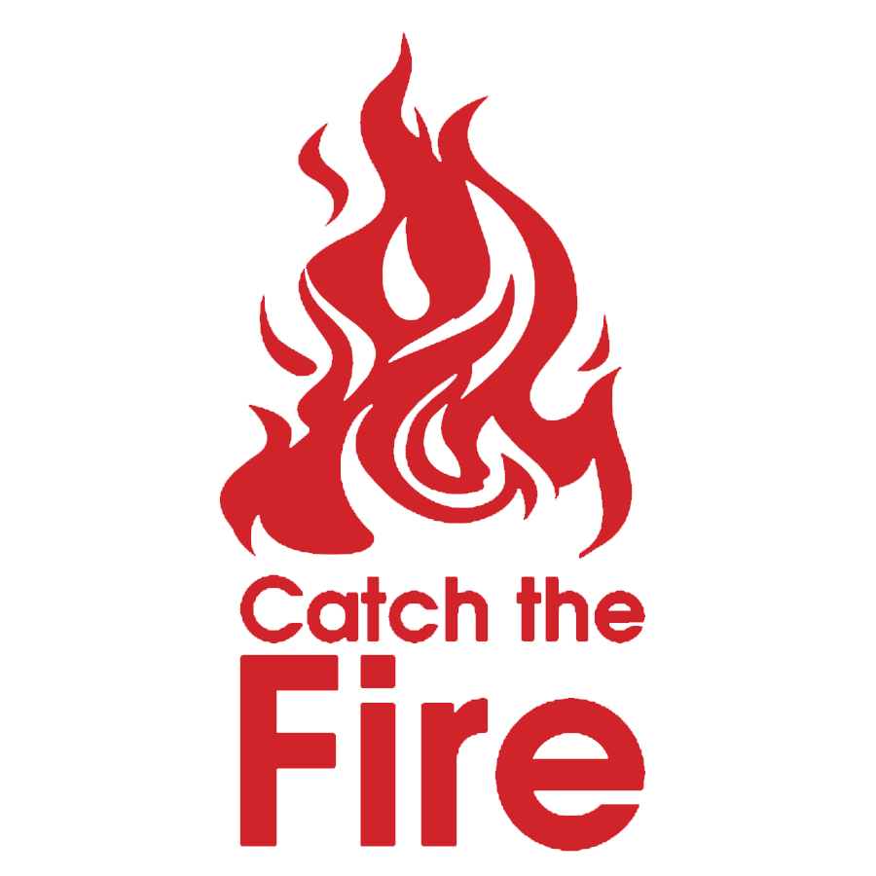

Catch the Fire Feedback Form

Thank you for attending the first catch the fire summer program. We would like to have your feedback to help us to improve the experience for others who take part in years to come.

Please circle the answer most relevant to your experience.

We aimed to create an intimate setting where biblical stories could be shared with adults in a relaxed environment. Did we achieve our goal?

Yes No

We aimed to leave room for personal testimony to be shared in fellowship. Did we achieve our goal?

Yes No

The stories were written from the perspective of the character. Please input on the length of the stories

Too long Too short Just right

Where you able to engage with the stories on a personal level depending on the character?

Yes No

Did you have a favourite character?

Adam Anna Jonathan Martha

Would you attend another catch the fire?

Yes No

Would you recommend Catch the Fire to a friend?

Yes No

Please suggest a character from the bible that you would like to hear from in this format.

_________________________________________________________________________________

Please make any suggestions that would help to improve the experience for others.

______________________________________________________________________________________________________________________________________________________________________________________________________________________________________________________